This document is a running methods document for the LANDIS-II portion of the Lake Tahoe West project. It describes data collection/analysis, calibration, and results organized by model extension. Note that all parameters used, as well as the version of extension used are all available on GitHub at: https://github.com/LANDIS-II-Foundation/Project-Lake-Tahoe-2017

Contents

Net Ecosystem Carbon Nitrogen (NECN) 2

NECN input maps 2

Soil physical property/quality maps 2

Soil carbon maps 2

Dead wood maps 4

Initial Communities 4

Soil Decay rates 5

Species Parameters 5

SCRAPPLE 9

Methods 9

1. Ignition 9

2. Fire Spread (Growth) 11

3. Fire Intensity 16

4. Fire Severity 16

Harvest 19

SCENARIO 1 20

SCENARIO 2: WUI Focused 20

SCENARIO 3: WUI Extended 23

SCENARIO 4: WUI Extended Rx Focus 26

Base BDA 30

Climate Change 32

# Net Ecosystem Carbon Nitrogen (NECN)

This section records the translation process from NECN v4.x (and earlier) to NECN 6.0 (and later) inputs. For each new input, we created a method for translating existing older inputs into newer inputs. If no method can be found for translation, new inputs will be mode with data source suggestions. The largest change was the elimination of ecoregions, which are replaced by a series of maps containing soils data.

This will be specific for the PSW Lake Tahoe West project, but will probably be pertinent for similar input translation for other projects. There is a companion spreadsheet for this called ‘Input_Translator.xlsx’ in the same directory as this.

## NECN input maps

### Soil physical property/quality maps

SSURGO is incomplete for the basin, so some of these are just constants at the climate region scale that I adapted from Louise’s work (Loudermilk et al. 2013, Loudermilk et al. 2014). Source is denoted next to name.

SoilDepthMapName - SSURGO

SoilDrainMapName- SSURGO

SoilBaseFlowMapName

SoilStormFlowMapName

SoilFieldCapacityMapName

SoilWiltingPointMapName

SoilPercentSandMapName

SoilPercentClayMapName

### Soil carbon maps

InitialSOM1CsurfMapName - ORNL

InitialSOM1NsurfMapName - ratio

InitialSOM1CsoilMapName - ORNL

InitialSOM1NsoilMapName- ratio

InitialSOM2CMapName - ORNL

InitialSOM2NMapName- ratio

InitialSOM3CMapName - ORNL

InitialSOM3NMapName- ratio

For the soil carbon maps, data was downloaded from the Oak Ridge National Laboratory distributed active archive <https://daac.ornl.gov/SOILS/guides/West_Soil_Carbon.html>

To partition total soil carbon into the various pools, we used the ratio of pools from Louise Loudermilk’s work and applied them to the new ORNL spatially dynamic values. Her previous total soil carbon value was 3475 g C m-2: SOM1surf (75 g C m-2; 2.16% of total), SOM1soil (100 g C m-2; 2.88%), SOM2 (3000 g C m-2; 86.33%), SOM3 (300 g C m-2; 8.63%). We used raster calculator to create individual SOM pool maps.

The new total soil carbon values are:

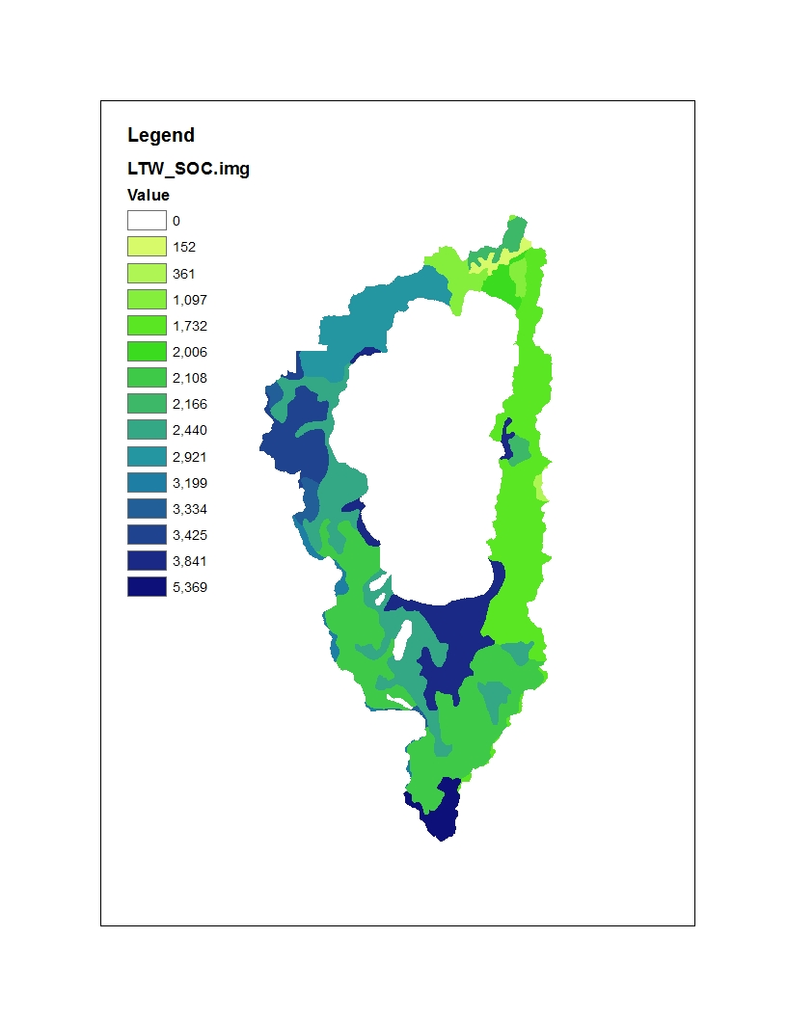

It appears that prior inputs were slightly over predicting soil carbon, especially on the east shore, but not substantially across the landscape.

For the Soil N maps, we based values on the default NECN C:N ratios of the pools, described as:

*One of the most difficult parts of initializing the model is estimating the C, N, P, and S levels for the different soil fractions. In most soils the* ***active soil fraction is approximately 2 to 4% of the total soil C****. The* ***slow SOM fraction makes up approximately 55%*** *of the total SOM. Unfortunately there is not a good technique for estimating the size of the stabilized* ***microbial products pool; however, it is estimated that it is approximately 10 to 20% of the soil****. The* ***passive SOM generally makes up 30 to 40% of the total SOM*** *and will have a higher value for high clay content soils.* ***The best estimate of the N content of these fractions are that the slow fraction has a C:N ratio of 15 to 20, the active SOM has a C:N ratio of 8 to 12, while the passive SOM has a C:N ratio of 7 to 10.*** *These approximations seem to work well for a large number of different soils.*

We used the guidelines above to develop these parameters.

|  |  |  |  |
| --- | --- | --- | --- |
|  | Century name | % of total C | C/N ratio |
| SOM1surf | Microbial | 1 | 10 |
| SOM1soil | Active | 2 | 10 |
| SOM2 | Slow | 59 | 17.5 |
| SOM3 | Passive | 38 | 8.5 |

### Dead wood maps

Source of C_deadwood information was from: <https://www.fs.usda.gov/rds/archive/Product/RDS-2013-0004>. Raster calculator was used to convert between units. Per cell ratio of dead woody debris to AGB was calculated as a check for consistency.

Wilson, Barry Tyler; Woodall, Christopher W.; Griffith, Douglas M. 2013. Forest carbon stocks of the contiguous United States (2000-2009). Newtown Square, PA: U.S. Department of Agriculture, Forest Service, Northern Research Station. <https://doi.org/10.2737/RDS-2013-0004>

InitialDeadWoodSurfaceMapName – SurfDead.tif

Belowground carbon in FIA is defined as Carbon in the belowground portion of the tree.

*The carbon (pounds) of coarse roots >0.1 inch in root diameter. Calculated for live trees with a diameter ≥1 inch, and dead trees with a diameter ≥ 5 inches, for both timber and woodland species. This is a per tree value and must be multiplied by TPA_UNADJ to obtain per acre information. Carbon is assumed to be one-half the value of belowground biomass as follows: CARBON_BG = 0.5 * DRYBIO_BG*

*The average proportion of coarse roots to total aboveground biomass is calculated using this equation:*

*root_ratio = Exp(JENKINS_ROOT_RATIO_B1 + JENKINS_ROOT_RATIO_B2 / (DIA*2.54))*

*partially defined by:*

*Species category*

*JENKINS_ROOT_RATIO_B1*

*Softwood (S)*

*-1.5619*

*Hardwood (H)*

*-1.6911*

*Species category*

*JENKINS_ROOT_RATIO_B2*

*Softwood (S)*

*0.6614*

*Hardwood (H)*

*0.8160*

We used the FIA equation from above and applied it to our initial communities AGB info to get coarse live roots and then used a 0.4 conversion factor to get dead roots (Melissa Lucash, *personal communication*). This will require getting diameter info from FIA info that Louise Loudermilk compiled, called ‘forest_age_estimates.csv’, which acts as a crosswalk for initial communities information.

### Initial Communities

Forest_age_estimates.xlsx in “K:\Loudermilk\Loudermilk\SNPLMA\LTBdata\FIA\SAS_FIA” contains all data needed to retrace FIA -> InitialCommunity process. We extracted biomass of each cohort from this spreadsheet and assign it to the appropriate cohort in the IC text file. However, there are multiple trees per age cohort, so we had to convert tons/acre from multiple cohorts into Mg/ha.

*Biomass expansion factor*

FIA uses a ‘biomass expansion factor’ (BEF) to convert individual tree biomass to tons/acre. The expansion factor is based on a trees per acre (TPA) calculation, which is:

TPA = 1/(N*A), where N = # of subplots, A = area of subplot

So, for standard plot design

TPA (trees per acre) = 6.018046.

The TPA used can be found in the TPA_UNADJ column

### Soil Decay rates

Soil decay rates were formerly within the Ecoregion parameters, but now they are landscape wide. We used the same decay rates as previous simulations.

## Species Parameters

Original species parameters were carried over from Loudermilk et al. 2013 for the LTB area, see Table 1 and Table 2. However, certain species were not behaving as expected. Some of this issue was related to climate inputs (changes from CMIP3 to CMIP5). Adjustments were proposed for shade tolerance and GDD minimum and maximum.

Known issues:

1. Red fir (AbieMagn) was experiencing substantial decline from year 1
2. PinuCont, PinuMont, TsugMert, PinuAlbi, have minimal regeneration. Limitations were related to GDD/temperature parameters.
3. Substantial increases in Sugar Pine biomass.

Potential solutions:

1. Adjusting GDD parameters to match 10 and 90th percentiles for those species based on USGS climate atlas.
2. Adjusting impacts of fir engraver on red fir (by lowering susceptibility).
3. Increasing maximum biomass cap on red fir.
4. Increase sugar pine susceptibility to mountain pine beetle.
5. Introduce white pine blister rust as mortality agent.

Table 1.

|  |  |  |  |  |  |  |  |  |  |  |  |  |
| --- | --- | --- | --- | --- | --- | --- | --- | --- | --- | --- | --- | --- |
| Species parameters |  | Sex-ual | Shade |  |  | Fire | Seed Disp-ersal | Disper-sal | Veg | Veg Sprout Age | Veg Sprout Age | Post-Fire |
| Species | Long-evity | Matu-rity | Tol. | Shade source | Changes? | Tol. | Effect-ive Distan-ce | Maxim-um Distan-ce | Repro-duction | Min | Max | Regen |
| PinuJeff | 500 | 25 | 2 | Jenkinsen, Silvics Manual. "The species is intolerant of shade" | Change to 1 | 5 | 50 | 300 | 0 | 0 | 0 | none |
| PinuLamb | 550 | 20 | 3 | Kinlock and Scheuner, Silvics Manual. " Sugar pine tolerates shade better than ponderosa pine but is slightly less tolerant than incense-cedar and Douglas-fir and much less so than white fir (14)." | Change to 2? | 5 | 30 | 400 | 0 | 0 | 0 | none |
| CaloDecu | 500 | 30 | 3 | Powers and Oliver, Silvics Manual, "Incense-cedar has been rated as more shade tolerant (22) than the associated pines and Douglas-fir (16), and perhaps less tolerant than white fir and grand fir." | Hold? | 5 | 30 | 1000 | 0 | 0 | 0 | none |
| AbieConc | 450 | 35 | 4 | Laacke, Silvics Manual. "In general, white fir becomes established best in partial shade, but once established grows best in full sunlight. It is less tolerant of shade than associated true firs (except red fir), is slightly more tolerant than Douglas-fir, and is much more tolerant than pines or oaks (37,41,56). Because white fir can survive and grow beneath heavy brush cover and eventually overtop the brush and dominate the site, many pure stands exist in otherwise mixed conifer areas (36)." | Hold? | 3 | 30 | 500 | 0 | 0 | 0 | none |
| AbieMagn | 500 | 40 | 3 | Laacke, Silvics Manual. "Although red fir grows best in full sunlight, it can survive and grow for long periods in relatively dense shade. Red fir's tolerance of shade appears to be less than that of mountain hemlock, slightly less than that of white fir and Brewer spruce, but greater than that of all of its other associates. Red fir's capacity to maintain significantly more foliage under shade than white fir suggests that the tolerance difference between them is marginal (1). It is most accurately classed as tolerant of shade. Red fir seedlings are slightly more hardy in full sun than white fir seedlings but become established most easily in partial shade (14,26). " | Increase to 4? | 4 | 30 | 500 | 0 | 0 | 0 | none |
| PinuCont | 250 | 7 | 1 | Lotan and Critchfield, Silvics Manual. "Lodgepole pine is very intolerant of shade and competition from other plant species." | Hold | 2 | 30 | 300 | 0 | 0 | 0 | none |
| PinuMont | 550 | 18 | 3 | Graham, Silvics Manual. "It is classed as intermediate in shade tolerance when compared to other northwestern tree species." | Change to 2? | 4 | 30 | 800 | 0 | 0 | 0 | none |
| TsugMert | 800 | 20 | 5 | Means, Silvics Manual. "Mountain hemlock is classed as tolerant of shade and other forms of competition (10,48,55)" | Hold | 1 | 30 | 800 | 0.0005 | 100 | 800 | none |
| PinuAlbi | 900 | 30 | 3 | Arno and Hoff, Silvics Manual. "Although whitebark pine has been tentatively rated very intolerant of competition or shade (12), recent observers (8,25,60,66,71) believe that it is intermediate or intolerant, about equivalent to western white pine or interior Douglas-fir. Whitebark pine is less tolerant than subalpine fir, spruce, and mountain hemlock; however, it is more tolerant than lodgepole pine and alpine larch." | Change to 2? | 2 | 30 | 2500 | 0.0001 | 100 | 900 | none |
| PopuTrem | 175 | 15 | 1 | Perala, Silvics Manual. "In both the eastern and western parts of its range, quaking aspen is classed as very intolerant of shade, a characteristic it retains throughout its life." | Hold | 2 | 30 | 1000 | 0.9 | 1 | 175 | resprout |
| NonnResp | 80 | 5 | 2 |  |  | 1 | 30 | 550 | 0.85 | 5 | 70 | resprout |
| NonnSeed | 80 | 5 | 2 |  |  | 1 | 30 | 1000 | 0 | 0 | 0 | none |
| FixnResp | 80 | 5 | 1 |  |  | 1 | 30 | 500 | 0.75 | 5 | 70 | resprout |
| FixnSeed | 80 | 5 | 1 |  |  | 1 | 30 | 800 | 0 | 0 | 0 | none |

Table 2.

|  |  |  |  |  |  |  |  |  |  |
| --- | --- | --- | --- | --- | --- | --- | --- | --- | --- |
| Species | Species Functional |  | GDD |  | GDD |  | Min Jan |  |  |
|  | Type | N-fix? | Min | 10% value from Atlas | Max | 90% value from atlas | Temp | Drought | Leaf Longevity | Epicormic Resprout? |
| PinuJeff | 1 | N | 555 | 1200 | 2149 | 2800 | -5 | 0.94 | 6 | N |
| PinuLamb | 1 | N | 815 | 1300 | 2866 | 2800 | -5 | 0.9 | 2.5 | N |
| CaloDecu | 1 | N | 837 | 1400 | 2938 | 3100 | -18 | 0.99 | 4 | N |
| AbieConc | 1 | N | 540 | 700 | 2670 | 2500 | -10 | 0.93 | 8 | N |
| AbieMagn | 1 | N | 483 | 1100 | 1257 | 1700 | -10 | 0.87 | 8 | N |
| PinuCont | 1 | N | 276 | 500 | 1230 | 1300 | -18 | 0.87 | 3.5 | N |
| PinuMont | 1 | N | 155 | 500 | 1220 | 1800 | -18 | 0.82 | 7 | N |
| TsugMert | 1 | N | 235 | 500 | 1200 | 1400 | -18 | 0.8 | 4.5 | Y |
| PinuAlbi | 1 | N | 230 | 300 | 1205 | 1200 | -18 | 0.9 | 5.5 | Y |
| PopuTrem | 2 | N | 600 | 600 | 3000 | 3000 | -10 | 0.82 | 1 | Y |
| NonnResp | 3 | N | 400 | 400 | 4000 | 4000 | -10 | 0.99 | 1.5 | Y |
| NonnSeed | 3 | N | 400 | 400 | 4000 | 4000 | -10 | 0.97 | 1.5 | N |
| FixnResp | 3 | Y | 400 | 400 | 4000 | 4000 | -10 | 0.97 | 1.5 | Y |
| FixnSeed | 3 | Y | 400 | 400 | 4000 | 4000 | -10 | 0.99 | 1.5 | N |

References:

Loudermilk et al. 2013 and 2014

USFS Silvics Manual

USGS Climate Atlas

# SCRAPPLE

## Methods

We included three types of fires in the model: Lightning, Human Unintentional (‘Accidental’), and Prescribed Fire (‘RxFire’). Each has its own ignition and suppression and intensity patterns. All fires behave similarly in regards to spread and mortality. Our model consists of four primary algorithms: Ignition, Spread, Fire Intensity, and Fire Severity, described below.

### 1. Ignition

Our ignitions follow a “supply and allocation” model whereby the supply of ignitions are generated from a zero-inflated Poisson model and then ignitions are allocated across the landscape with an ignition surface.

For Accidental and Lightning fires, the number of ignitions per day is determined from empirical data relating the number of ignitions (by each of three types) to FWI. The following equation was fit to available ignition and climatic data (Zuur et al 2009).

Number of fires = eb0 + b1*FWI (Equation 1)

This is a zero-inflated Poisson distribution, which requires fitting two parameters, which vary by ignition type. Fire Weather Index (FWI) follows the calculations from the Canadian Fire Prediction System (1992) and is a smoothed averaged that integrates long- and short-term variation in precipitation and temperature. FWI was calculated for each day-of-the-year and the appropriate number of ignitions were generated for each day. For fractional ignitions (i.e. number of ignitions = 1.6), simple rounding will determine the number of ignitions. The location of each ignition is determined below.

In order to parameterize ignitions, historical fire data from 1992-2013 for the LTB (Short 2013) was used to establish a relationship between daily number of ignitions and FWI. Ignition within the historical data set were separated by ignition type into lightning (coded as ‘lightning’ within the Short data) and human accidental (many codes, including ‘campfire’, ‘arson’, and ‘child’, were combined). Daily historical FWI was calculated from daily temperature and precipitation data (PRISM) as implemented within the Climate Library of LANDIS-II (Lucash et al. 2017), which produced daily FWI values for our period of record. A zero inflated Poisson distribution was then fitted using the ‘zeroinfl’ function within the ‘pscl’ package in R, producing estimates for b0 and b1 in equation 1. This was done for both lightning ignitions and human accidental ignitions. The analysis was conducted using the likelihood package in R (R Core Team 2014).

We tested these parameters by providing our fitted equation with daily FWI values to observe how many ignitions values were produced. The procedure was verified using random FWI values produced by a random number generator within R. Below are the results of feeding daily FWI values from 1992-2013 back into our fitted equation for lightning ignitions, to attempt to mimic the historical ignitions data used to fit the equation.

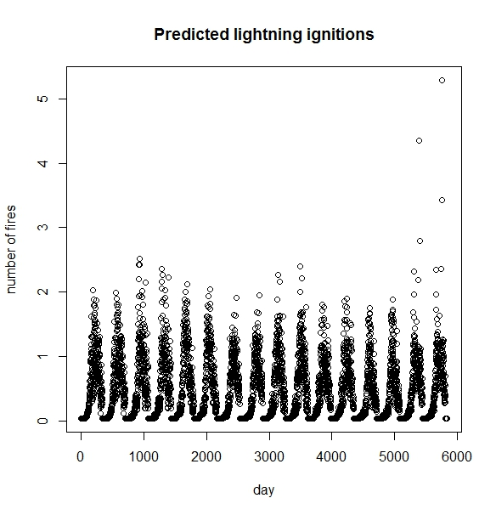

*Figure 1: Example of predicted lightning ignitions per day for 16 years of historical FWI data using SCRAPPLE method.*

For RxFire, a set number of fires are generated per year, based on expert input and/or scenario design. For each day of the year, a single RxFire is attempted, given that FWI is within a specified range and that the wind speed is below an allowable maximum. RxFires are attempted sequentially (by day of year) until the expected number of fires is successfully ignited. Conditions are placed on RxFire ignitions based on a minimum FWI (necessary to maintain fire spread, below), a maximum FWI (conditions under which prescribed fire would be avoided), and a maximum wind speed (again, conditions under which prescribed fire would be avoided).

#### 1.1 Ignition Locations

A continuous weighted surface of historic ignitions occurrences is generated for each of the three ignition types from the fire record data and used to allocate ignitions. For regions where ignitions have no spatial pattern, this surface would be a constant value or a smoothed average of ignition rates (see some of Finney’s national-scale modeling work). For other regions, the spatial pattern of ignitions could be predicted (Yang et al. 2015). For this study we used historical fire data from 1992-2013 for the LTB (Short 2013). All available sites are then randomly shuffled, with an algorithm that biases selection by the weights provided; ignition locations begin at the top of the shuffled list. The list of ignitions sites is re-shuffled at the beginning of each year.

In combination, the three ignition sources generate the total number of fires per year per fire type and is highly dependent upon FWI.

Our model produces an output map of fire ignitions, coded by type (e.g. Lightning = 1, Accidental = 2, Rx = 3). To calibrate fire ignitions, we ran simulations in R to validate that fire ignition parameters recreate the appropriate number of fires given a particular FWI value. We also calibrated each ignition type such that the spatial patterns of fire ignitions provided by the input maps match the spatial patterns of fire ignitions by type in the output maps.

2. Fire Spread (Growth)  
From the point of ignition, fire spreads. Fire can spread to each adjacent cell dependent upon a probability of spread (Pspread) to adjacent neighbor (out of four nearest neighbors). Fire spread is from cell-to-cell and determines fire size. A fire will continue burning until no more cells are selected for spread.

Fire spread was built from a general equation relating event probability to FWI (Beverly and Wotton 2007):

Probability of Fire Spread = 1 / 1 + eβ0 Equation 2

Where β0 is the probability of spread into a site given condition on that site:   
β0 = β0’ + β1 * FWI + β2*EffectiveWindSpeed + β3*FineFuels Equation 3

Where EffectiveWindSpeed is an adjusted wind speed whereby reported wind speed and direction for the region (from meteorological stations) is downscaled to individual sites by accounting for slope angle and the slope azimuth relative to the wind direction (see Nelson 2002 for complete information). EffectiveWindSpeed also incorporates the intensity of the source fire. A high severity fire burning upslope generates a greater EffectiveWindSpeed than a moderate or light fire. This in turn feeds back into the estimate of fire intensity (see below), creating self-sustaining high-intensity fires under certain conditions.

For our model fit from empirical data, we used fine fuel load (mass) estimates from LANDFIRE fuel types (Table 1). During model execution, fire fuels are estimated from endogenous (internal to the model framework) litter estimates. Notably, during model execution, fine fuels are dynamic over time to reflect reductions from fuel treatments or prescribed fire and additions from overstory mortality, e.g., from insect outbreaks (e.g., Sturtevant et al. 2009).

A fire will spread until it has reached a maximum area for the day. Spread area was drawn from the GEOMAC fire perimeter data (Table X) and is defined as the increase in day-to-day area of total fire perimeter. Maximum area is determined empirically:

Maximum daily spread area = β0 + β1 * FWI + β2*EffectiveWindSpeed Equation 4

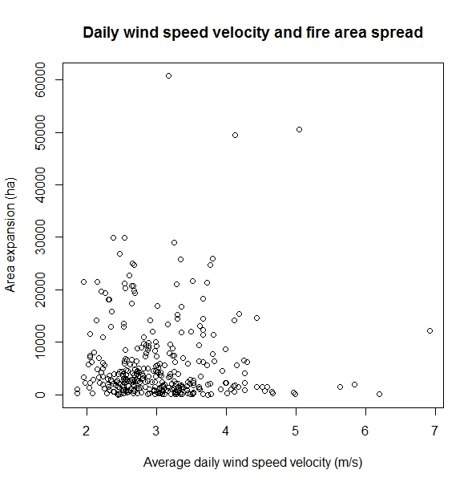

*Figure 2: Daily fire spread area (ha) and daily wind speed velocity. Daily fire spread within SCRAPPLE is a function of both daily wind speed velocity and FWI.*

Maximum area spread parameters were derived using a fitted generalized linear model, function ‘glm’ in the R statistical software. It is important to note that the FWI and Effective wind speed parameters used to determine maximum daily spread area entirely separate from, and derived differently from the parameters fit to determine successful cell-to-cell fire spread (described below). In simulations, cell-to-cell and maximum daily fire spread are updated with daily FWI estimates until the fire can no longer spread (e.g. disconnected fuels), FWI levels reduces spread rates, or suppression is applied.

To estimate the fire spread parameters, spatial data are needed for daily FWI, daily wind speed, daily wind direction, and fine fuel loading for a set of reference fires. Daily fire perimeters are then overlain on each of the datasets to extract successful and unsuccessful spread areas. For the purposes of the Lake Tahoe West project, fire perimeters were polyline layers and each of the fire spread variables were raster datasets. Unsuccessful/successful spread areas could then be identified as unsuccessful/successful spread cells and tracked throughout the period of record.

Our approach allows unburned islands within perimeters which are important ecologically and may cover 20% of the area within a perimeter.

*Data and parameterization*

We used the Sierra Nevada boundary defined by the Sierra Nevada Conservancy to derive the data below (see Figure 3). Because fire suppression is modeled as a separate process, we chose this area as being broadly representative of the conditions found in the LTB, there are many more fires (larger sample size), and fires in the area are typically not extensively suppressed due to the rugged terrain.

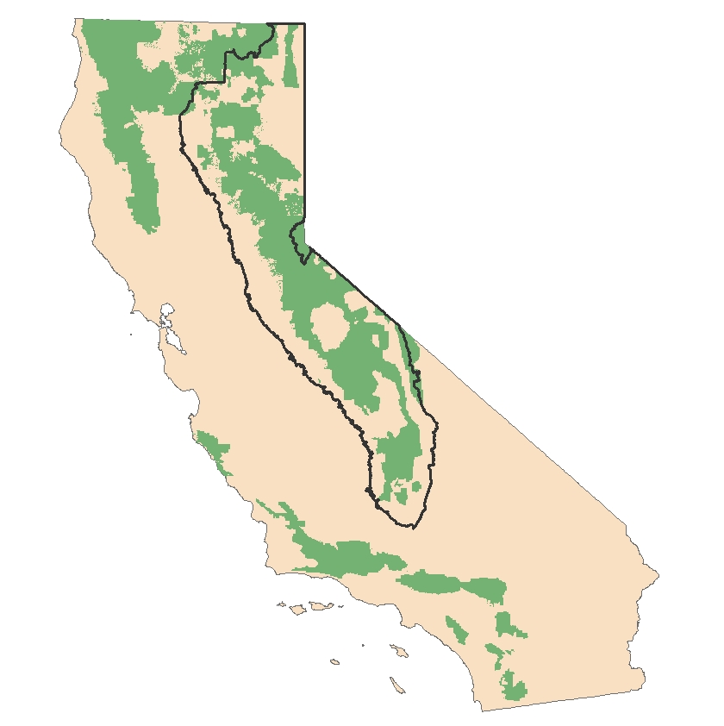

*Figure 3: Sierra Nevada analysis area for generating fire extension parameters for the Lake Tahoe West project, outlined in black. Green areas represent Forest Service administrative boundaries.*

Table 1. The following data sources were used to parameterize Lake Tahoe West.

|  |  |
| --- | --- |
| Data | Source |
| Daily fire perimeters | GEOMAC from all available years (2000-2016). Data required preprocessing, which included year-to-year attribute name standardization, date convention standardization, geographic coordinate standardization, removal of blank or missing records, elimination of duplicate record days, elimination of days with ‘negative’ fire spread, etc <https://rmgsc.cr.usgs.gov/outgoing/GeoMAC/historic_fire_data/> |
| Fire Weather Index (FWI), Daily | Daily FWI was calculated using equations internal to the Climate Library (Lucash et al. 2017). Climate data used was Mauer daily gridded historical climate data available through the USGS GeoDataPortal. <https://cida.usgs.gov/gdp/>. The climate data was produced for EPA level II ecoregions, which was then resampled into 30mx30m pixels to make it consistent with all other input maps. |
| Fine fuel loads | Fine fuel load maps were developed using LANDFIRE cover types and the associated fuel loading information (Reeves etal 2006) <https://www.landfire.gov/documents/FuelProceedings.pdf> |
| Daily wind speed | Daily wind speed data used were summarized by the USGS GeoDataPortal, using the same EPA region mapping approach and resolution resampling as the FWI data. |
| Daily wind direction | Because a continuous surface of historical daily wind direction is not available, we estimated wind direction as the direction of fire spread; daily fire polygon centroid-to-centroid azimuth was used as daily wind direction. Wind direction is not a direct input to fire spread, but rather is included in the effective wind speed calculation. |

After the raster data were processed for extent and resolution, successful and unsuccessful spread cells were extracted based on daily fire progression. ‘Unsuccessful’ cells were defined as those that fell on a fire perimeter that did not burn on the following day. Parameter values were then estimated using a modified zero inflated Poisson distribution. This modified form creates a 0-1 probability function which is then applied at a daily time step to determine the success of cell-to-cell fire transmission.

2.1 Suppression  
Suppression accounts for the capacity to reduce the rare, or probability of fire spread and is unique for each fire type. Suppression is implemented as four zones per fire type: none, minimal, moderate, maximal suppression. Each zone is assigned an integer reflecting suppression effectiveness that reduce Pspread as a fraction (effectiveness / 100). Zones are inputs as unique maps for each fire type. The unique maps allow for different kinds of suppression dependent upon circumstances. For example, lightning generated fires may be allowed to naturally spread in more remote areas. Accidentally started fires may be heavily suppressed in all areas.

Our suppression algorithms account for changes in suppression as function of FWI whereby resources for suppression are typically allocated more during more extreme fire weather (higher FWI). Two FWI breakpoints determine when suppression efforts are increased. In addition, a maximum wind speed limit limits suppression to days when resources can be safely deployed.

Suppression zones were based on the 2014 multi-jurisdictional Tahoe Fire and Fuels plan (data provided by Mason Bindl at Tahoe Regional Planning Agency). We used the Threat and Defense Zone to identify three levels of suppression ranging from highly (~95%), moderately (~65%), and very low suppression (~5%).

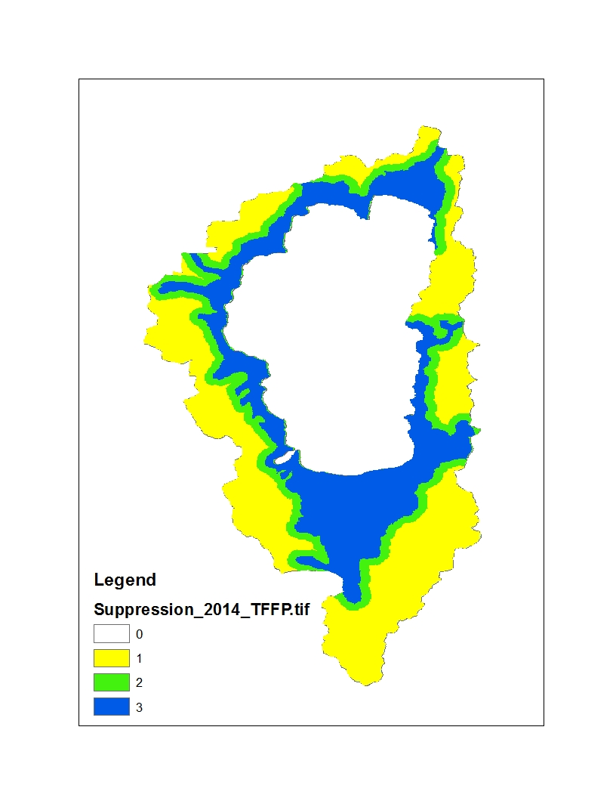

One known issue was that the scenario designers wanted a "paint the corners" approach to fire management. However, the same level of suppression effort was used across all scenarios, instead of allowing lightning fires to burn in wilderness areas under Scenario 4.

### 3. Fire Intensity

We developed three classes of fire intensity, Low: < 4’ flame lengths; Moderate: 4-8’; and High: >8’. These intensity classes correspond to metrics of intensity commonly used by fire managers. Corresponding mortality severity classes were also defined (see below).

Unlike fire ignition and spread, empirical data of fire intensity are not available at the regional scale. Although dNBR data exist, they do not readily translate into intensity classes that can be related to expert opinion and mortality. Therefore, we used a multi-condition risk approach to determine whether a site burned at low (< 4’), moderate (4-8’), or high intensity. We defined three risk conditions:

1. Does the mass (g m-2) of fine fuels exceed a pre-determined risk level?
2. Does the mass (g m-2) of ladder fuels exceed a pre-determined risk level? Ladder fuels are assigned via a list of species with maximum ages that can be regarded as ‘ladder fuels’. For example, white spruce aged 0-25 might be regarded as ladder fuels.
3. Is the fire intensity of the source site (the neighboring site from where a fire spread) high intensity? A high severity fire will promote high severity fire as it spreads.

The default is low intensity. If one of these three conditions is true, the intensity become moderate. If two or more conditions are true, the fire is high intensity. Relationships between these three conditions and historical fire intensity were created by assigning historical fires one of the three fire intensity classes described above and extracting the fuel loading data that corresponded to that fire (data from Forest Service Region 5 GeoSpatial Information Center <https://www.fs.usda.gov/detail/r5/landmanagement/gis/?cid=STELPRDB5327833>). Fire intensity data is drawn from the same broad Sierra Nevada geography as spread parameters, avoiding potential sampling bias towards small high intensity fires which are most prominent in the Basin.

### 4. Fire Severity

Fire severity is the mortality caused by fire at each site and varies depending on the tree species and ages present. A low severity fire, for example, may cause extensive mortality if the forest is dominated by fire-intolerant tree species. For each fire intensity class, a fire severity table is defined that includes the age ranges and associated probability of mortality for each tree species. A single random number is drawn for each burned site (ensuring a consistent effect on all trees). If Pmortality (from the corresponding fire severity table) exceeds the random number, the cohort is killed. Biomass loss is determined by cohort mortality. These data were collected using an expert opinion approach whereby five fire experts for the LTB provided estimates of mortality for varying species and age combinations. These data were collected independently and collated and areas of disagreement (indicated by high variance among experts) discussed and refined. See the following table for mortality values by species-age class.

|  |  |  |  |  |  |  |  |  |  |
| --- | --- | --- | --- | --- | --- | --- | --- | --- | --- |
|  | Fire Severity Class 1 | | | Fire Severity Class 2 | | | Fire Severity Class 3 | | |
| Species | Age (lower bound) | Age (upper bound) | Probability of Mortality | Age (lower bound) | Age (upper bound) | Probability of Mortality | Age (lower bound) | Age (upper bound) | Probability of Mortality |
| PinuJeff | 0 | 40 | 0.45 | 0 | 40 | 0.6 | 0 | 40 | 0.9 |
| PinuJeff | 40 | 80 | 0.1 | 40 | 80 | 0.25 | 40 | 80 | 0.8 |
| PinuJeff | 80 | 500 | 0.05 | 80 | 500 | 0.15 | 80 | 500 | 0.7 |
| PinuLamb | 0 | 40 | 0.45 | 0 | 40 | 0.7 | 0 | 40 | 0.9 |
| PinuLamb | 40 | 80 | 0.1 | 40 | 80 | 0.2 | 40 | 80 | 0.8 |
| PinuLamb | 80 | 500 | 0.05 | 80 | 500 | 0.1 | 80 | 500 | 0.6 |
| CaloDecu | 0 | 40 | 0.5 | 0 | 40 | 0.75 | 0 | 40 | 0.9 |
| CaloDecu | 40 | 80 | 0.15 | 40 | 80 | 0.2 | 40 | 80 | 0.7 |
| CaloDecu | 80 | 500 | 0.1 | 80 | 500 | 0.1 | 80 | 500 | 0.5 |
| AbieConc | 0 | 40 | 0.6 | 0 | 40 | 0.8 | 0 | 40 | 0.99 |
| AbieConc | 40 | 80 | 0.15 | 40 | 80 | 0.4 | 40 | 80 | 0.75 |
| AbieConc | 80 | 450 | 0.05 | 80 | 450 | 0.2 | 80 | 450 | 0.8 |
| AbieMagn | 0 | 40 | 0.6 | 0 | 40 | 0.8 | 0 | 40 | 0.99 |
| AbieMagn | 40 | 80 | 0.15 | 40 | 80 | 0.25 | 40 | 80 | 0.75 |
| AbieMagn | 80 | 500 | 0.05 | 80 | 500 | 0.1 | 80 | 500 | 0.8 |
| PinuCont | 0 | 30 | 0.6 | 0 | 30 | 0.85 | 0 | 30 | 0.99 |
| PinuCont | 30 | 70 | 0.35 | 30 | 70 | 0.7 | 30 | 70 | 0.95 |
| PinuCont | 70 | 250 | 0.25 | 70 | 250 | 0.6 | 70 | 250 | 0.9 |
| PinuMont | 0 | 40 | 0.55 | 0 | 40 | 0.77 | 0 | 40 | 0.9 |
| PinuMont | 40 | 80 | 0.15 | 40 | 80 | 0.3 | 40 | 80 | 0.75 |
| PinuMont | 80 | 550 | 0.1 | 80 | 550 | 0.25 | 80 | 550 | 0.6 |
| TsugMert | 0 | 30 | 0.6 | 0 | 30 | 0.8 | 0 | 30 | 0.9 |
| TsugMert | 30 | 70 | 0.2 | 30 | 70 | 0.5 | 30 | 70 | 0.75 |
| TsugMert | 70 | 800 | 0.1 | 70 | 800 | 0.3 | 70 | 800 | 0.6 |
| PinuAlbi | 0 | 30 | 0.65 | 0 | 30 | 0.8 | 0 | 30 | 0.97 |
| PinuAlbi | 30 | 70 | 0.3 | 30 | 70 | 0.5 | 30 | 70 | 0.8 |
| PinuAlbi | 70 | 900 | 0.1 | 70 | 900 | 0.4 | 70 | 900 | 0.7 |
| PopuTrem | 0 | 30 | 0.5 | 0 | 30 | 0.9 | 0 | 30 | 0.99 |
| PopuTrem | 30 | 70 | 0.3 | 30 | 70 | 0.7 | 30 | 70 | 0.95 |
| PopuTrem | 70 | 175 | 0.1 | 70 | 175 | 0.6 | 70 | 175 | 0.9 |
| NonnResp | 0 | 10 | 0.6 | 0 | 10 | 1 | 0 | 10 | 1 |
| NonnResp | 10 | 40 | 0.7 | 10 | 40 | 1 | 10 | 40 | 1 |
| NonnResp | 40 | 80 | 0.8 | 40 | 80 | 1 | 40 | 80 | 1 |
| NonnSeed | 0 | 10 | 0.6 | 0 | 10 | 1 | 0 | 10 | 1 |
| NonnSeed | 10 | 40 | 0.7 | 10 | 40 | 1 | 10 | 40 | 1 |
| NonnSeed | 40 | 80 | 0.8 | 40 | 80 | 1 | 40 | 80 | 1 |
| FixnResp | 0 | 10 | 0.6 | 0 | 10 | 1 | 0 | 10 | 1 |
| FixnResp | 10 | 40 | 0.7 | 10 | 40 | 1 | 10 | 40 | 1 |
| FixnResp | 40 | 80 | 0.8 | 40 | 80 | 1 | 40 | 80 | 1 |
| FixnSeed | 0 | 10 | 0.6 | 0 | 10 | 1 | 0 | 10 | 1 |
| FixnSeed | 10 | 40 | 0.7 | 10 | 40 | 1 | 10 | 40 | 1 |
| FixnSeed | 40 | 80 | 0.8 | 40 | 80 | 1 | 40 | 80 | 1 |

# Harvest

**Scenarios are based solely on west shore for acres**

* While scenario acreage targets are based on LTW only, percent of acres within LTW compared to the entire Lake Tahoe Basin are very similar. The only difference is that LTW has a higher percentage of wilderness compared to the LTB, while the LTB has a higher percentage of general forest – especially in steep slopes compared to LTW (see appendix A).

**Stand Delineation**

* Everything over 116 ha (~7062 total ha) were split into smaller polygons at maximum of 116 – keeping larger end
* Evaluated TPA, Seral Class, Slope, LMU, Vegetation type: CWHR, Channel, drainages, ridge top roads
* Final stand delineation based on CWHR types and slope classes (0-30, 30-50, 50-70, >70%)

**Management Zones**

* Management zones were developed using the stand delineation and treatment available (treatment available was based on distance from road, and slope with the assumption that the following priority took place: ground mechanical, aerial mechanical, hand thinning)
* The underlying layers do not change between scenarios; however, the treatment zones do because they incorporate treatment type.
* Each stand was assigned a management zone based on management zone that had its centroid in the stand
* Each stand was assigned road distance of <1000 feet or between 1000 feet and 0.5 miles if the polygon was completely within that distance of the road.

**KNOWN ISSUES:**

These were issues found in the original parameterization. Fixes were either incorporated into existing model runs or left for the next model round.

1. **SALVAGE LOGGING**

GOAL:

* 1. Salvage is a priority over live thinning and occurs in both WUI Defense and WUI Threat. 90% of the area that experienced a high mortality event (from either fire or insects) would be salvaged prior to new live thinning occurring. 40% of the salvaged area would be replanted with: 80% Jeffrey pine, 10% cedar, 5% red fir, 5% sugar pine.

WHAT HAPPENED:

* 1. Salvage logging was NOT implemented as expected. However, it could be added in the next round. Replanting did NOT occur. Note that the materials harvested do not appear within the harvest log file. Instead, they show as a reduction in the deadwood pool maps from the NECN extension.

1. **STAND RE-ENTRY**

GOAL:

* 1. Re-entry after harvest or disturbance was to be set at the dominant mean FRI types for each management zone.

WHAT HAPPENED:

* 1. Stands were re-entered more than expected. MinTimeSinceDamage was the only restriction used when MinTimeSinceHarvest should also have been used. Additional replicates were run with the fixes:
     1. Scenario 2: stand re-entry occurs at 20 years after disaster/harvest.
     2. Scenario 3 & 4: stand re-entry occurs at 11 years.
  2. The result of the changes was increased stand carbon since fewer young cohorts were wiped out. There were also fewer harvest events that resulted in nothing coming off the landscape.

1. **HARVEST RESIDUES:**

GOAL:

* 1. 60% of hand thinning and 80% of mechanical thinning woody residue to be harvested.

WHAT HAPPENED:

* 1. Only 5% of woody harvest residues were removed. Additional replicates were run with the corrected harvest targets.

## SCENARIO 1

The suppression only scenario does not have any separate management zones as all zones receive 100% suppression. No other management activities occur in this scenario.

## SCENARIO 2: WUI Focused

Scenario 2 is focused on business as usual. This scenario focuses on hand and mechanical treatments in the WUI, with 75% of the treatments occurring in the defense zone (750 acres/year) and the other 25% occurring in the threat zone (250 acres/year). During May 1st to November 1st, 80% of the treatments are hand thin treatments, while 20% of the treatments are mechanical treatments. Eighty percent of the stand is thinned each time it is treated with 26% of the total biomass removed using ground based mechanical and 8% of the total biomass removed using hand thinning. There is no prescribed fire in this scenario and all wildfires have 100% suppression. Salvage is a priority over green forest treatments and can occur on 90% of the land within the WUI up to the allocated annual acres. Reforestation occurs on 40% of the salvaged acres. Stands can be re-entered after 20 years post disturbance (post-disturbance includes thinning treatments, wildfire, and salvage).

(*note 80% of the stand being treated during each entry is based on data from South Shore Fuels).

*Management Zones*

There are five management zones in this scenario.

* Defense Mechanical: This is the zone within the defense zone that can be treated with mechanical ground based equipment that can treat on less than 30% slopes and up to 1000 feet from any existing road.
* Defense Hand: This is the zone within the defense that cannot be treated with mechanical equipment and has a slope less than 70%.
* Threat Mechanical: This is the zone within the threat zone that can be treated with mechanical ground based equipment that can treat on less than 30% slopes and up to 1000 feet from any existing road.
* Threat Hand: This is the zone within the threat zone that cannot be treated with mechanical equipment and has a slope less than 70%.
* No Treatment: This is the area that does not receive any treatment as part of scenario 2. It is land found in the general forest and wilderness.
* N/A: This is the area within the defense and threat zones that cannot be treated because the slope is greater than 70%.

Table 1: Management zones for scenario 2 based on management area plus treatment type, with annual acres and percentage treated and total available acres to treat in the zone.

|  |  |  |  |  |  |
| --- | --- | --- | --- | --- | --- |
| **Management Area** | **Treatment** | **Treatment Allocation By Zone** | **Annual Treatment Acres** | **Total Annual Acres** | **Total Acres Available** |
| WUI Defense Zone | Mechanical | 20% | 150 | 750 | 6545 |
| Hand | 80% | 600 | 10189 |
| WUI Threat Zone | Mechanical | 20% | 50 | 250 | 2512 |
| Hand | 80% | 200 | 12217 |
| General Forest | No treatment | 0 | 0 | 0 | 27025 |
| Wilderness |
| NA | NA | 0 | 0 | 0 | 89 |

*Acre targets*

* Acres targets for year were based on the average for entire basin: 2000 hand thin, 500 mechanical, 100 prescribed, 800 pile burning
  + Based on ratio of hand to mechanical thinning we allocated 80% hand and 20% to mechanical
* Based on the average acres treated across the LTB, we selected 1,000 acre per year thinning/ salvage target; note: planting does not influence this treatment based on Salvage acres
* In order to set treatment area targets within the Harvest extension, the average area treated by mechanical and hand prescriptions per year by management area was compiled (below).
* The average treatment in the defense zone was 73.5% compared to 22.9% threat zone – we therefore selected a ratio of 75:25% defense:threat.

Table 2: Historic LTB data identifying hectares treated per year defined by target area (Lake Tahoe West, CA, and NV broken out between defense and threat zones).

|  |  |  |  |  |  |  |  |  |  |
| --- | --- | --- | --- | --- | --- | --- | --- | --- | --- |
| **Zone** | **LTW-Defense** | **LTW-Threat** | **LTW-General** | **CA-Defense** | **CA-Threat** | **CA-General** | **NV-Defense** | **NV-Threat** | **NV-General** |
| **Code\*** | 8 | 7 | 9 | 5 | 4 | 6 | 2 | 1 | 3 |
| **Hectares** | 6865 | 6117 | 10846 | 14335 | 7634 | 17437 | 7652 | 6001 | 7748 |
| **Mean treated area /yr (ha)** | 216.3 | 101.96 | 0 | 283.05 | 34.1 | 0 | 193.7 | 112.3 | 0 |
| **Percentage of each zone treated** | 68.0 | 32.0 | 0.0 | 89.2 | 0.1 | 0.0 | 63.3 | 36.7 | 0.0 |

*Biomass Targets*

Mechanical thinning is ground based only and can occur on up to 30% slope and up to 1000 ft from existing road. 80% of dead biomass is removed during thinning operations.

Table 3: Percent of live species removed by size classes using mechanical thinning for scenario 2.

|  |  |  |  |  |  |  |
| --- | --- | --- | --- | --- | --- | --- |
| **Mechanical** | IC | JP | LP | SP | WF/RF | Total % Size Class |
| <10 | 10.71 | 9.54 | 39.37 | 4.20 | 29.17 | 93.00 |
| 10-12 | 8.07 | 7.19 | 29.67 | 3.16 | 21.98 | 70.07 |
| 12-14 | 7.54 | 6.71 | 27.70 | 2.95 | 20.52 | 65.43 |
| 14-16 | 6.58 | 5.86 | 24.19 | 2.58 | 17.92 | 57.14 |
| 16-18 | 5.18 | 4.62 | 19.05 | 2.03 | 14.12 | 45.00 |
| 18-20 | 3.70 | 3.30 | 13.61 | 1.45 | 10.08 | 32.14 |
| 20-22 | 2.63 | 2.35 | 9.68 | 1.03 | 7.17 | 22.86 |
| 22-24 | 2.01 | 1.79 | 7.38 | 0.79 | 5.47 | 17.43 |
| 24-26 | 1.48 | 1.32 | 5.44 | 0.58 | 4.03 | 12.86 |
| 26-28 | 0.89 | 0.79 | 3.27 | 0.35 | 2.42 | 7.71 |
| 28-30 | 0.49 | 0.44 | 1.81 | 0.19 | 1.34 | 4.29 |

DBH was cross-walked to age using methods developed by Angela White (USFS). Biomass reductions were set equal to the ‘Total % Size class’ reductions above, assuming that species differences would be determined by the community at a given treated site. **IC: incense cedar, JP: Jeffrey pine, SP: sugar pine, WF/RF: white fir and red fir combined

Hand thinning can occur on slopes up to 70% slopes. 60% of dead biomass removed during thinning operations

Table 4: Percent of live species removed by size classes using hand thinning for scenario 2 and 3.

|  |  |  |  |  |  |  |
| --- | --- | --- | --- | --- | --- | --- |
| **Hand Thin** | IC | JP | LP | SP | WF/RF | Total % Size Class |
| <10 | 7.60 | 6.77 | 27.94 | 2.98 | 20.70 | 66.00 |
| 10-12 | 4.44 | 3.96 | 16.33 | 1.74 | 12.10 | 38.57 |
| 12-14 | 4.44 | 3.96 | 16.33 | 1.74 | 12.10 | 38.57 |

**IC: incense cedar, JP: Jeffrey pine, SP: sugar pine, WF/RF: white fir and red fir combined

Suppression occurs at 100% in all areas regardless of management zone.

## SCENARIO 3: WUI Extended

Scenario 3 is focused on using increased pace and scale with vegetation thinning treatments driving the structure of the forest. This scenario focuses on hand and mechanical treatments in the WUI, and general forest with hand treatments occurring in the wilderness as well. Increased pace of 4000 acres of treatment annual with 45% of the treatments occurring in the defense zone (1800 acres/year), 25% occurring in the threat zone (1000 acres/year), 25% occurring in the general forest (1000 acres), and 5% occurring in the wilderness (200 acres/year). During May 1st to November 1st, the proportion of treatments that are allocated to ground based mechanical, aerial based mechanical, and hand thinning are proportional to the total acres within each zone (see Table 5 for specific allocations). Eighty percent of the stand is thinned each time it is treated with 55% of the total biomass removed using ground based mechanical and 8% of the total biomass removed using hand thinning. In order to increase the pace and scale several factors have been pushed including increased biomass removal compared to scenario 2, increased slope accessibility for treatments using ground based equipment (up to 50% slope) and aerial based equipment (up to 70% slope and within 0.5 miles from a road), and increased DBH limits for removal (38”). There is no prescribed fire in this scenario and all wildfires have 100% suppression. Salvage is a priority over green forest treatments and can occur on 90% of the land within the WUI defense and up to 60% of the land within the WUI treat and general forest up to the allocated annual acres. Reforestation occurs on 40% of the salvaged acres. Stands can be re-entered after 11 years post disturbance (post-disturbance includes thinning treatments, wildfire, and salvage) which is based on the dominant mean fire return interval for the landscape (see Appendix D).

*Management Zones*

There are 11 management zones in this scenario.

* Defense Ground Mechanical: This is the zone within the defense zone that can be treated with mechanical ground based equipment that can treat on less than 50% slopes and up to 1000 feet from any existing road.
* Defense Aerial Mechanical: This is the zone within the defense zone that can be treated with aerial based equipment that can treat on less than 70% slopes and up to 0.5 miles from any existing road. The zones were defined so that if ground based mechanical could be used it would be.
* Defense Hand: This is the zone within the defense that cannot be treated with mechanical equipment and has a slope less than 70%.
* Threat Ground Mechanical: This is the zone within the threat zone that can be treated with mechanical ground based equipment that can treat on less than 50% slopes and up to 1000 feet from any existing road.
* Defense Aerial Mechanical: This is the zone within the threat zone that can be treated with aerial based equipment that can treat on less than 70% slopes and up to 0.5 miles from any existing road. The zones were defined so that if ground based mechanical could be used it would be.
* Threat Hand: This is the zone within the threat zone that cannot be treated with mechanical equipment and has a slope less than 70%.
* General Forest Ground Mechanical: This is the zone within the general forest that can be treated with mechanical ground based equipment that can treat on less than 50% slopes and up to 1000 feet from any existing road.
* General Forest Aerial Mechanical: This is the zone within the general forest that can be treated with aerial based equipment that can treat on less than 70% slopes and up to 0.5 miles from any existing road. The zones were defined so that if ground based mechanical could be used it would be.
* General Forest: This is the zone within the general forest that cannot be treated with mechanical equipment and has a slope less than 70%.
* Wilderness: This is the area within Wilderness with less than 70% slope that can be treated with hand thinning.
* N/A: This is the area within the broader area with a slope greater than 70% than cannot be treated.

Table 5: Management zones for scenario 3 based on management area plus treatment type, with annual acres and percentage treated and total available acres to treat in the zone.

| **Management Area** | **Treatment\*** | **Treatment Allocation By Zone** | **Annual Treatment Acres** | **Total Annual Acres** | **Total Acres Available** |
| --- | --- | --- | --- | --- | --- |
| WUI Defense | G Mechanical | 44 | 794 | 1800 | 7386 |
| A Mechanical | 3 | 59 | 544 |
| Hand | 53 | 947 | 8804 |
| WUI Threat | G Mechanical | 23 | 226 | 1000 | 3326 |
| A Mechanical | 3 | 25 | 369 |
| Hand | 75 | 749 | 11034 |
| General Forest | G Mechanical | 8 | 83 | 1000 | 1130 |
| A Mechanical | 11 | 113 | 1551 |
| Hand | 80 | 804 | 10983 |
| Wilderness | Hand | 100 | 200 | 200 | 12773 |
| NA | NA | 100 | 0 | 0 | 677 |

*G stands for ground based mechanical and A stands for aerial based mechanical

**If these management zones need to be further collapsed, aerial and ground based could be merged because they have the same biomass removals. If this occurred the acres and allocation would just be summed. However, they were kept separate at this point for potential need from water quality modeling and for tracking nuance, which theoretically could be tracked post model runs. This would reduce the total model runs from 10 to 7.

*Acre targets*

* Acres targets for year were developed based on Landscape Resilience Assessment (LRA). There are 38,284 acres of non-resilient Trees Per Acre based on LRA, which was rounded up to 40,000
* It was then determined that if we wanted to treat all these acres over 10 years 4,000 acres would need to be treated annually year

*Biomass Targets*

Mechanical thinning

Ground based treatments can occur on up to 50% slope and up to 1000 ft from existing road. 80% of dead biomass is removed during thinning operations. This treatment does not occur in the wilderness. An increase to 50% slope was selected because a self-levelling cab excavator can go up to 50% slope and this pushes the slope limits to maximum that LTW would consider.

Aerial based treatments (yarding-cable/helicopter) can occur on up to 70% slope and within 0.5 miles of a road. Distance to road was determined based on average distance helicopter can thin, which varies based on elevation, slope, etc. Ground based treatments occur as priority over aerial treatments.

Biomass removal is the same regardless of method. 55% of the biomass is removed (see appendix B and C for methodology). 80% of dead biomass removed during thinning operations.

Table 6: Total acres by slope class for each management area within 1000 feet of a road.

|  |  |
| --- | --- |
| **Within a 1000ft of a Road** | **Acres** |
| **General Forest** | **3,894** |
| >70% | 175 |
| 0-30% | 2,023 |
| 30-40% | 591 |
| 40-45% | 193 |
| 45-50% | 206 |
| 50-70% | 704 |
| N/A | 2 |
| **WUI - Defense** | **14,521** |
| >70% | 295 |
| 0-30% | 10,535 |
| 30-40% | 1,356 |
| 40-45% | 446 |
| 45-50% | 454 |
| 50-70% | 1,365 |
| N/A | 71 |
| **WUI - Threat** | **10,647** |
| >70% | 159 |
| 0-30% | 7,415 |
| 30-40% | 1,431 |
| 40-45% | 390 |
| 45-50% | 375 |
| 50-70% | 854 |
| N/A | 23 |
| **Grand Total** | **29,062** |

Table 7: Percent of live species removed by size classes using mechanical thinning for scenario 3 with no tree greater than 38” DBH being removed (Appendix B).

|  |  |  |  |  |  |  |
| --- | --- | --- | --- | --- | --- | --- |
| **Populated Species/Size Class** | IC | JP | LP | SP | WF/RF | Total % Size Class |
| <10 | 10.95 | 9.75 | 40.22 | 4.29 | 29.80 | 95.00 |
| 10-12 | 10.95 | 9.75 | 40.22 | 4.29 | 29.80 | 95.00 |
| 12-14 | 9.79 | 8.72 | 35.99 | 3.83 | 26.66 | 85.00 |
| 14-16 | 9.79 | 8.72 | 35.99 | 3.83 | 26.66 | 85.00 |
| 16-18 | 9.79 | 8.72 | 35.99 | 3.83 | 26.66 | 85.00 |
| 18-20 | 8.64 | 7.70 | 31.75 | 3.38 | 23.53 | 75.00 |
| 20-22 | 8.06 | 7.18 | 29.64 | 3.16 | 21.96 | 70.00 |
| 22-24 | 6.91 | 6.16 | 25.40 | 2.71 | 18.82 | 60.00 |
| 24-26 | 4.03 | 3.59 | 14.82 | 1.58 | 10.98 | 35.00 |
| 26-28 | 2.30 | 2.05 | 8.47 | 0.90 | 6.27 | 20.00 |
| 28-30 | 1.15 | 1.03 | 4.23 | 0.45 | 3.14 | 10.00 |
| 30-32 | 1.15 | 1.03 | 4.23 | 0.45 | 3.14 | 10.00 |
| 32-34 | 1.15 | 1.03 | 4.23 | 0.45 | 3.14 | 10.00 |
| 34-36 | 1.15 | 1.03 | 4.23 | 0.45 | 3.14 | 10.00 |
| 36-38 | 0.58 | 0.51 | 2.12 | 0.23 | 1.57 | 5.00 |

*IC: incense cedar, JP: Jeffrey pine, SP: sugar pine, WF/RF: white fir and red fir combined

Hand thinning occurs in all management zones on slopes up to 70%. Total biomass removal will stay at 8% and be same species removal ratios as scenario 2 (Table 4) because it is not feasible to remove more material by hand across the landscape.

Suppression occurs at 100% in all areas regardless of management zone.

## SCENARIO 4: WUI Extended Rx Focus

Scenario 4 is focused on using increased pace and scale with fire driving the structure of the forest. Thinning treatments only occur in the defense zone and follow the same prescription as under scenario 2. Hand and mechanical treatments occur only in the WUI defense (750 acres/year). During May 1st to November 1st, 80% of the treatments are hand thin treatments, while 20% of the treatments are mechanical treatments. Eighty percent of the stand is thinned each time it is treated with 26% of the total biomass removed using ground based mechanical and 8% of the total biomass removed using hand thinning. Salvage only occurs in the WUI defense and is a priority over green forest treatments; this activity can occur on 90% of the land within the WUI defense up to the allocated annual acres. Reforestation occurs on 40% of the salvaged acres. Stands can be re-entered after 11 years post disturbance (post-disturbance includes thinning treatments, wildfire, and salvage), which is based on the dominant mean fire return interval for the landscape (see Appendix D). Suppression continues at 100% in the WUI defense. However, managed wildfire is allowed to burn in all other zones. Prescribed fire is used in all zones. The target acres of fire (weather prescribed or managed) will guide number of ignitions and percent suppression for scenario 4 inputs based on model iterations to test this. The goal is to burn 3250 acres of prescribed fire up to moderate severity in all zones annually.

*Management Zones*

There are six management zones in this scenario.

* Defense Mechanical: This is the zone within the defense zone that can be treated with mechanical ground based equipment that can treat on less than 30% slopes and up to 1000 feet from any existing road.
* Defense Hand: This is the zone within the defense that cannot be treated with mechanical equipment and has a slope less than 70%.
* Threat Burn: Threat zone where there will be no thinning and only burning will be allowed.
* General Forest Burn: General Forest where there will be no thinning and only burning will be allowed.
* Wilderness Burn: General Forest where there will be no thinning and only burning will be allowed.
* N/A: This is the area within the defense and threat zones that cannot be treated because the slope is greater than 70%.

Table 8: Scenario 4 management zones based on management area plus treatment type, with annual acres and percentage treated and total available acres to treat in the zone.

|  |  |  |  |  |  |  |
| --- | --- | --- | --- | --- | --- | --- |
| **Management Area** | **Treatment** | **Treatment Allocation By Zone** | **Annual Treatment Acres** | **Total Annual Acres** | **Total Acres Available** | **Target Acres Fire** |
| WUI Defense Zone | Mechanical/Burn | 20% | 150 | 750 | 6545 | 410 |
| Hand/Burn | 80% | 600 | 10189 | 640 |
| WUI Threat | Burn Only | 0 | 0 | 0 | 14751 | 1000 |
| General Forest | Burn Only | 0 | 0 | 0 | 13729 | 1000 |
| Wilderness | Burn Only | 0 | 0 | 0 | 13296 | 200 |
| NA | NA | NA | 0 | 0 | 67 | 0 |

*Acre targets*

* Acres targets for year were developed based on Landscape Resilience Assessment (LRA). There are 38,284 acres of non-resilient Trees Per Acre based on LRA, which was rounded up to 40,000
* It was then determined that if we wanted to treat all these acres over 10 years 4,000 acres would need to be treated annually year
* We determined that thinning would still occur within the defense zone due to structures and so that remained at 750 acres based on scenario 2. The remaining acres were then allocated among the remaining zones with a heavier emphasis on the defense zone treatments and a lighter emphasis on wilderness (similar to scenario 3 allocations).

*Biomass Targets*

Mechanical thinning is ground based only and can occur in the WUI defense on up to 30% slope and up to 1000 ft from existing road. 80% of dead biomass is removed during thinning operations. See table 3 for the percent of live species removed by size classes using mechanical thinning.

Hand thinning can occur on slopes up to 70% slopes in the WUI defense. 60% of dead biomass removed during thinning operations. See table 4 for percent of live species removed by size classes using hand thinning.

Salvage is a priority over live thinning and occurs in WUI Defense. 90% of the area that experienced a high mortality event (from either fire or insects) would be salvaged prior to new live thinning occurring. 40% of the salvaged area would be replanted with: 80% Jeffrey pine, 10% cedar, 5% red fir, 5% sugar pine.

Suppression occurs at 100% only in WUI defense. The other zones have managed wildfire during specific fire weather windows to meet total acreage targets of fire in other zones.

*Prescribed Fire*

Fire treatments are implemented differently in LANDIS compared to thinning treatments. Fire treatments are not confined to the stand map and therefore and not held to acreage. Inputs into LANDIS focus on number of ignitions, rather than acres. Alec will determine how many prescribed fires combined with how much suppression under certain conditions equal the target acreage and use this number as the number of ignitions and percent suppression in each zone. These values will not be the exact target acreage during time step. The ignition probability map (raster cell scale) for prescribed fire starts will be weighted by management zone so that more ignitions would start in defense zone to reach the higher acreage targets in this zone. In general, fires in the defense zone will be smaller than outside of the defense zone because of the level of effectiveness parameters that were set in LANDIS. In the WUI suppression is 90% effectives, in WUI buffer – 60% effective, and in general forest – 5% effective. While these numbers may seem intuitively low since the LTB on average is 90% effective at suppressing fire, regardless of zone – the values represent the size of fires that have occurred in the LTB and therefore are assumed to be a good representation of what has occurred as far as suppression.

The input parameters in respect to prescribed burning are provided below. The burn window is set through allowable wind speed and min and max fire weather index (FWI). Based on historical prescribed fire data, max wind speed was this at 24.79 mph and max FWI was approximately 13. In addition to wind speed and FWI, a cap on prescription intensity can be provided based on maximum prescription fire intensity which are tied to mortality values by age and species. Theoretically it is possible to have an escaped fire, however Alec has not been able to make it happen.

Prescribed Fire Parameters

* MaximumRxWindSpeed 8.0
* MaximumRxFireWeatherIndex 10.0
* MinimumRxFireWeatherIndex 8.0
* MaximumRxFireIntensity 2
  + This is based on allowable flame lengths: 1) <4ft, 2) 4-8 ft, 3) >8ft (note in the LRA we said that > 6 foot flame length was considered high severity and was undesirable if patches were above 40 acres). We selected intensity class 2 because a) it depends on stand conditions what effect of flame length is, b) it is more representative of pinning a corner, c) we recognize that fires may need to burn hotter to reach objectives, and d) small patches of higher severity are okay it is the large contiguous patches that indicate lower resilience. This may be a factor that we want to adjust in scenario 5.
* NumberRxAnnualFires 5 – this will be adjusted through iterations of model to reach target acres

*Additional Considerations Evaluated but not included*

Fire break zones were evaluated based on where fire breaks would be naturally established on the landscape. We evaluated two zones: Fire break outside defense: determined using a 100 m buffer from existing roads (everything on impervious roads and forest service maintenance) + LMU ridge top stands defined in EcObject + 100 m buffer on powerlines and Fire break inside defense: determined using a 100 m buffer from existing roads (everything on impervious roads and forest service maintenance) + LMU ridge top stands defined in EcObject + 100 m buffer on powerlines + structures with 100 m buffer. However, we decided not to use fire breaks in order to more completely “pin corners” of this scenario really focusing on using fire, and possibility that fire can be used as fuel break rather than thinning.

# Base BDA

We simulated three bark beetle species (JPB, MPB, and FEB) that cause the majority of insect mortality in the LTB. For many bark beetle species, climate influences outbreaks in three ways: low winter temperatures cause beetle mortality; year-round temperatures influence development and mass attack; and drought stress reduces host resistance. Here, we model climate influences as a function of drought and host density alone, recognizing that the full suite of climatic influences is necessary for a fully mechanistic model. For this project, outbreaks occur randomly between a set of minimum and maximum intervals (Table 1).

Bark beetle outbreaks (mortality that exceeds background mortality, which was captured in the NECN-H extension) were modeled using the Biological Disturbance Agent (BDA) extension. This extension simulates tree mortality from insect outbreaks and can represent multiple insects simultaneously. The BDA assigns insect-specific resource requirements and tree species-specific vulnerability that varies by cohort age. Within BDA, sites are probabilistically selected for disturbance based upon the host density at a given site; non-hosts reduce site disturbance probability. Disturbance probability therefore is an emergent property of host density that can be altered by other mortality agents, including wildfire and fuels management. Cohort mortality at an outbreak site is subsequently determined by species’ age and host susceptibility probabilities (Table 2). The susceptibility of each cohort to insect mortality was derived from empirical field studies and expert opinion. Following mortality, dead biomass remains on site and was either added to the downed woody debris C pool or the fine woody debris C pool.

Trees under 10 years old were immune/ignored by Fir engraver and JPB, with increasing vulnerability as the trees aged.

Table 1

|  |  |  |  |
| --- | --- | --- | --- |
|  | Fir Engraver | Jeffrey Pine Beetle | Mountain Pine Beetle |
| Pattern | Cyclic Uniform | Cyclic Uniform | Cyclic Uniform |
| Min interval | 10 | 10 | 10 |
| Max interval | 25 | 25 | 25 |
| Min time since | 5 | 5 | 5 |
| NeighborhoodFlag | No | No | Yes |
| NeighborhoodSpeedUp | None | None | 2x |
| Radius | 10,000m | 10,000m | 2,000m |
| Shape | Uniform | Uniform | Uniform |
| Weight | 20 | 20 | 20 |
| Dispersal Rate | 1000m/yr | 400m/yr | 600m/yr |
| Epidemic Threshold | 0.01 | 0.01 | 0.01 |
| Seed Epicenter | Yes | Yes | Yes |
| Seed Epicenter Coef | 0.01 | 0.01 | 0.01 |
| Dispersal Template | MaxRadius | MaxRadius | MaxRadius |

Table 2

|  |  |  |  |  |  |  |  |  |  |  |  |  |  |  |
| --- | --- | --- | --- | --- | --- | --- | --- | --- | --- | --- | --- | --- | --- | --- |
| Agent | Species Name | Minor Host Age | SRDProb | 2nd Host Age | SRDProb | Major Host Age | SRDProb | Susceptibility Class3 | MortProb | Susceptibility Class2 | MortProb | Susceptibility Class1 | MortProb | CFS |
| Fir Engraver | AbieConc | 0 | 0 | 10 | 0.99 | 60 | 0.99 | 0 | 0 | 10 | 0.15 | 60 | 0.35 | yes |
| Fir Engraver | AbieMagn | 0 | 0 | 10 | 0.9 | 60 | 0.8 | 0 | 0 | 10 | 0.05 | 60 | 0.15 | yes |
| JPB | PinuJeff | 0 | 0.1 | 20 | 1 | 25 | 1 | 0 | 0.1 | 40 | 0.5 | 120 | 0.1 | yes |
| MPB | PinuAlbi | 20 | 0.33 | 60 | 0.66 | 80 | 0.9 | 20 | 0.05 | 60 | 0.1 | 80 | 0.2 | yes |
| MPB | PinuLamb | 20 | 0.33 | 60 | 0.66 | 80 | 1 | 20 | 0.05 | 60 | 0.2 | 80 | 0.5 | yes |
| MPB | PinuCont | 20 | 0.33 | 60 | 0.66 | 80 | 0.9 | 20 | 0.05 | 60 | 0.1 | 80 | 0.2 | yes |
| MPB | PinuMont | 20 | 0.33 | 60 | 0.66 | 80 | 0.9 | 20 | 0.05 | 60 | 0.1 | 80 | 0.2 | yes |

White pine blister rust was not incorporated into this model at this time. There is limited information related to the rate of spread and impacts on overall mortality. It is expected to respond to increasing temperature and precipitation. However, there is not enough information to parameterize the extension at this time. One potential workaround would be to just raise the background mortality rate through adjusting the monthly wood mortality parameter in NECN.

References:

Jactel 1991

USFS Fir Engraver Facts

Schwilk 2006

Ferrel 1994

Joel Egan (USFS) conversation

MPB CFS Synthesis

Safranyik 2006

Cole and Amman????

Bradley and Tueller 2001

# Climate Change

**Notes:**

* The Maurer (historical gridded) data set is not particularly good in its representation of the historical trends that you will find in actual (pre-gridded) site observations.
* The Maurer data set does not do well capturing extreme events.
* The Maurer data set was used as a calibration source for the CMIP 3 projections (which explains the continuity with the climate data used by Louise).
* Maurer is also 2°C colder minimum temps than other comparable historical datasets.
* PRISM is likely the most “accurate” (per Mike Dettinger) at representing broadscale historical trends.
* PRISM and UIdaho are in line with CMIP5 projections.
* All climate projections are designed to represent trends at the sub-continental scale, not basin scale.

I do not know why the CanESM rcp 4.5 and GFDL rcp 8.5 were the projections selected—other than those were the same GCMs used by Loudermilk. Gridded climate data from 30 GCMs and rcps were provided by Mike Dettinger but were not analyzed. Ideally more than one GCM and rcp would be used.